# Project Design Phase-II

Technology Stack (Architecture & Stack)

Date: 20 June 2025

Team ID: LTVIP2025TMID55293

Project Name: HOUSE RENT APP USING MERN:

Maximum Marks: 4 Marks

## Technical Architecture

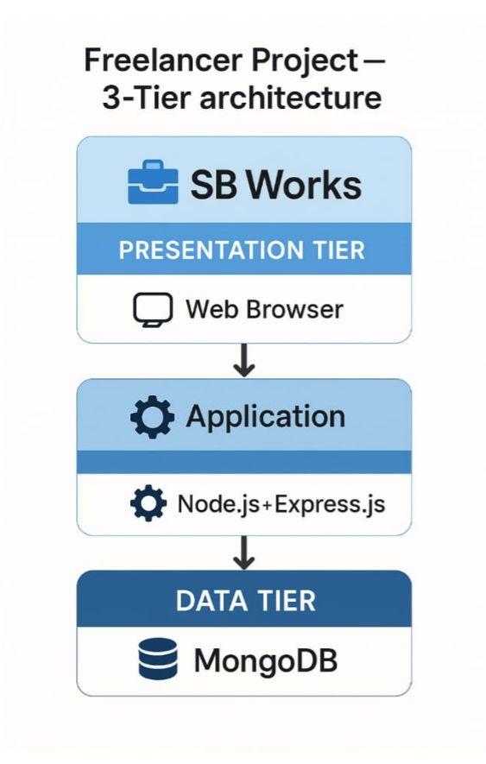

HouseHunt is built using a 3-tier architecture:  
1. Presentation Tier (User Interface)  
2. Application Tier (Backend Logic)  
3. Data Tier (Database and Storage)

Architecture Diagram:

[React Frontend]  
 ↓ (HTTP)  
[Node.js + Express Backend]  
 ↓ (Mongoose ODM)  
[MongoDB Atlas Cloud DB + File Storage (Multer/Cloudinary)]

## Table-1: Components & Technologies

|  |  |  |  |
| --- | --- | --- | --- |
| S.No | Component | Description | Technology |
| 1 | User Interface | Web UI for renters, owners, and admin | HTML, CSS, JavaScript, React.js |
| 2 | Application Logic-1 | Manages routing, authentication, services | Node.js, Express.js |
| 3 | Application Logic-2 | Frontend-backend communication, API handling | Axios, Express.js Controllers |
| 4 | Application Logic-3 | Filtering & search logic for listings | Express.js, MongoDB Queries |
| 5 | Database | Stores users, properties, bookings, etc. | MongoDB |
| 6 | Cloud Database | Cloud-hosted database | MongoDB Atlas |
| 7 | File Storage | Handles images for properties | Multer, Cloudinary / Local FS |
| 8 | External API-1 | Cloud image storage & access | Cloudinary API |
| 9 | External API-2 | Not used in this version | — |
| 10 | Machine Learning Model | Not used in this version | — |
| 11 | Infrastructure | Deployment setup (cloud/local) | Node Server, MongoDB Atlas |

## Table-2: Application Characteristics

|  |  |  |  |
| --- | --- | --- | --- |
| S.No | Characteristics | Description | Technology |
| 1 | Open-Source Frameworks | Stack used from open-source ecosystem | React.js, Node.js, Express.js, MongoDB |
| 2 | Security Implementations | Role-based access, password encryption, token auth | JWT, Bcrypt.js, Helmet.js, CORS |
| 3 | Scalable Architecture | Modular 3-tier design for horizontal scaling | MERN Stack |
| 4 | Availability | Cloud-hosted services with support for high uptime | MongoDB Atlas, Node.js Server |
| 5 | Performance | Optimized APIs, efficient DB access, fast rendering | MongoDB Indexes, React Virtual DOM, REST API |